**GIT&GITHUB TASK**

1)Install git.

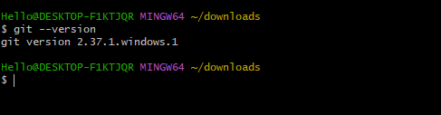

2)Create a repo in github with README.md and .ignore file.  
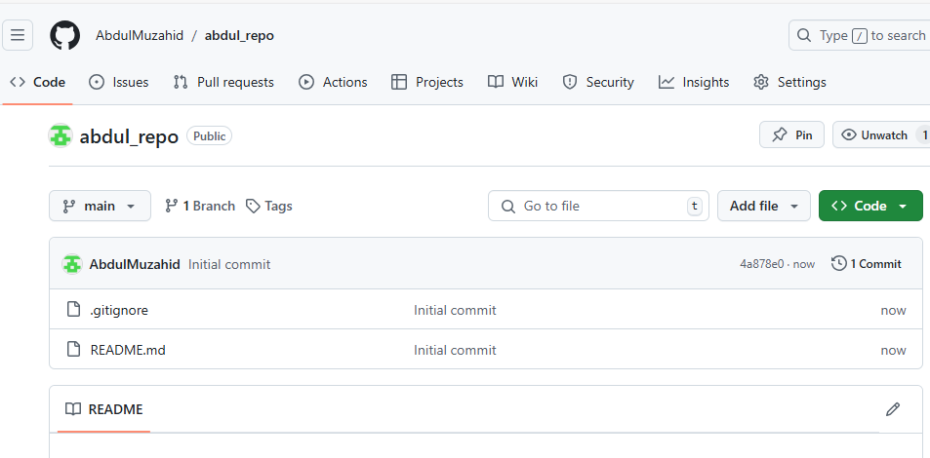

3)Clone the created repo to local.  
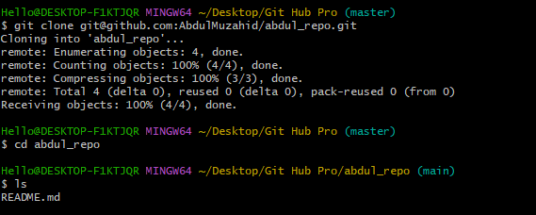

4)Create two files in local repo.  
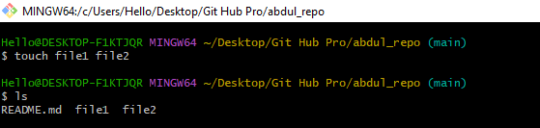

5)Commit two files and push to central Repository.  
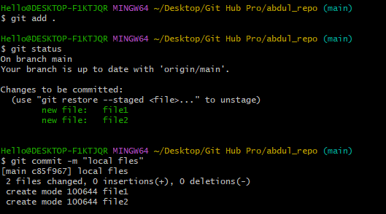

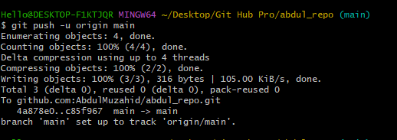

6) Create a branch in local and create a sample file and push to central.  
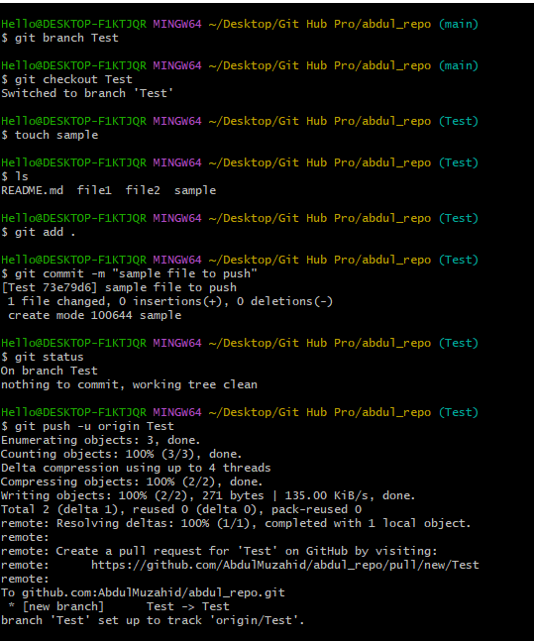

7) Create a branch in github and clone that to local.  
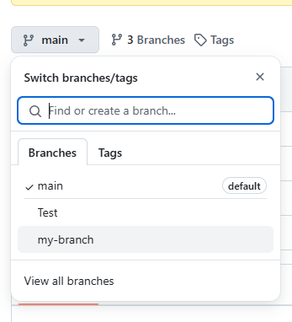

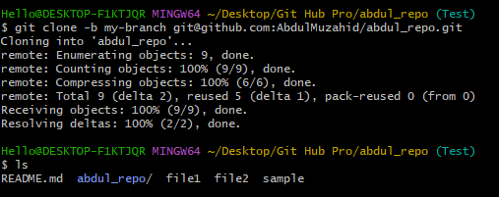

8)Merge the created branch with master in git local.  
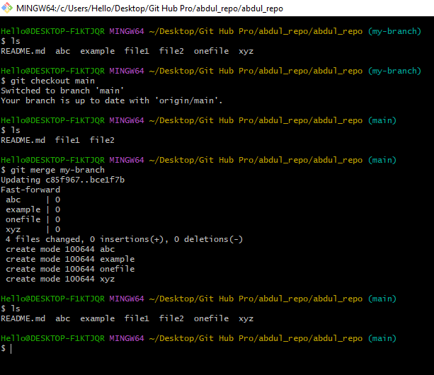

9) Merge the created branch with master in github by sending a pull request.  
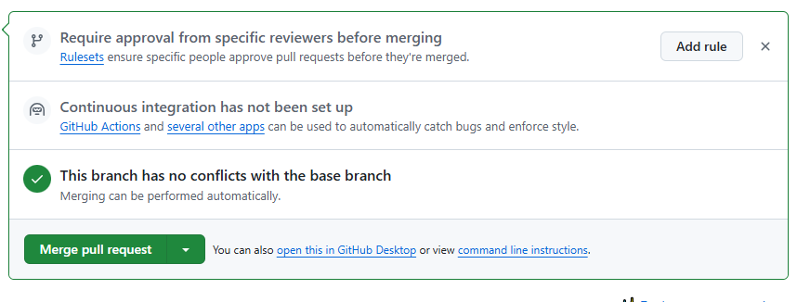

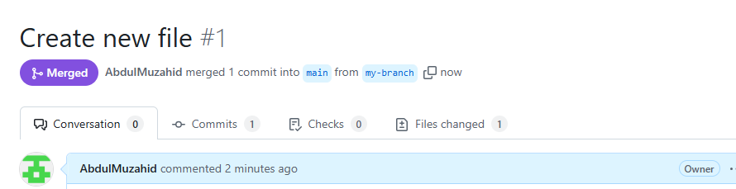

10)create a file in local and send that to branch in github.  
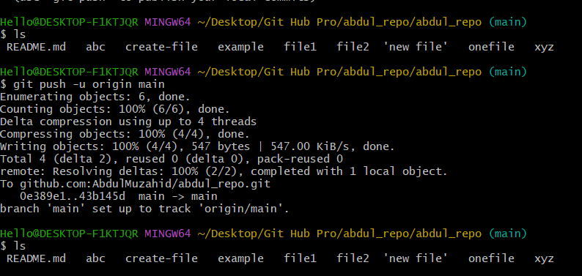

11)clone only a branch from github to local.  
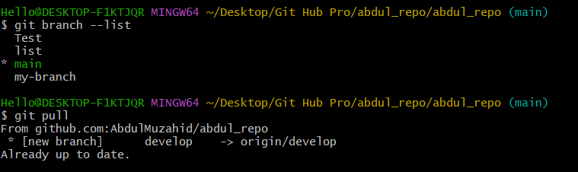  
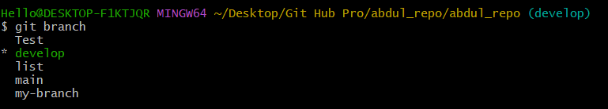

12)create a file with all passwords and make that un trackable with git.  
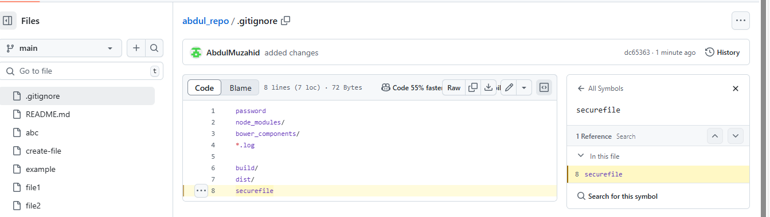

13)make a commit and make that commit reset without savings changes  
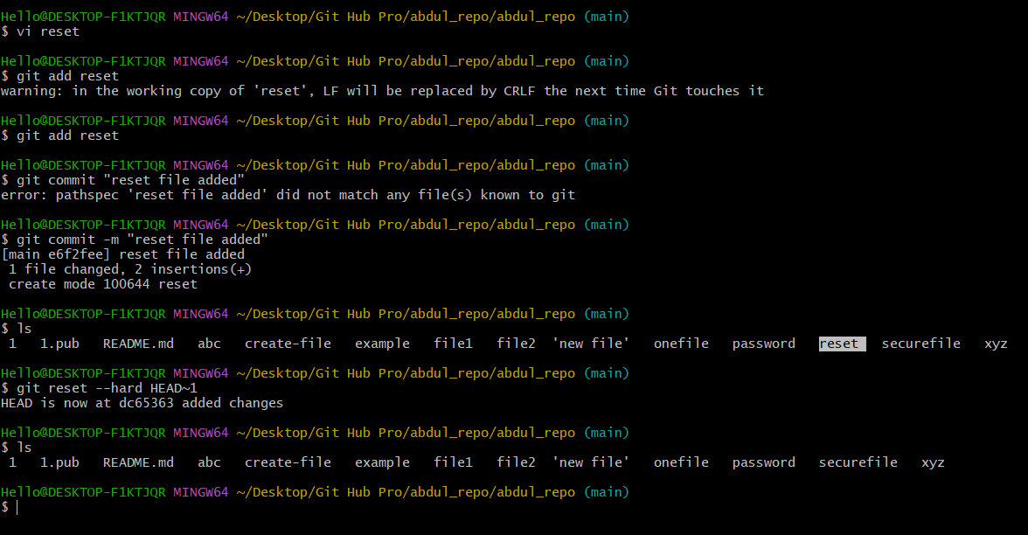

14)Revert a commited commit to the older version.  
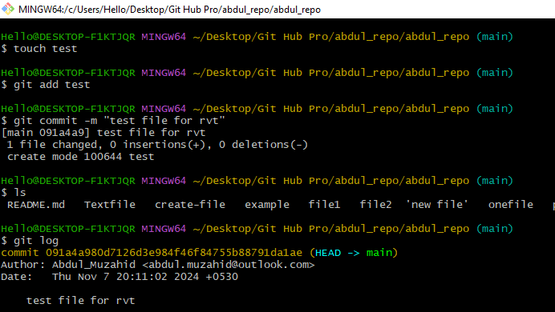

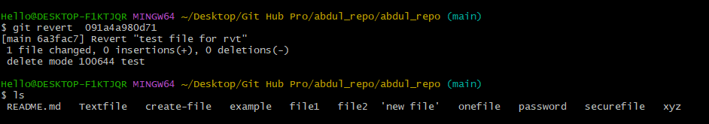

15) push a file to stash without savings the changes and work on another file.

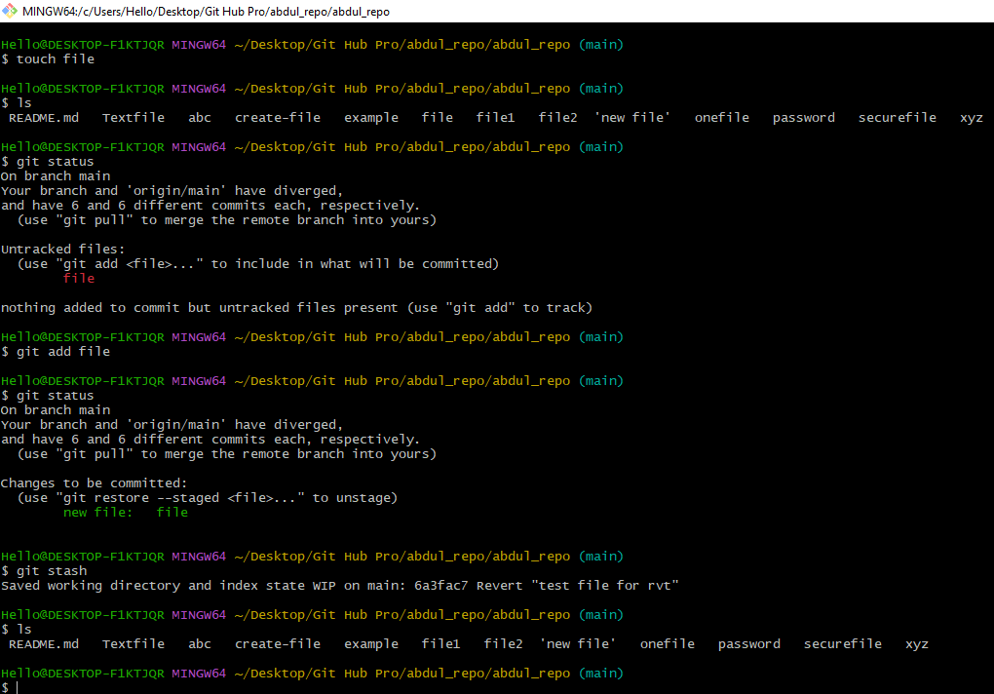

16)undo the stash file and start working on that again.  
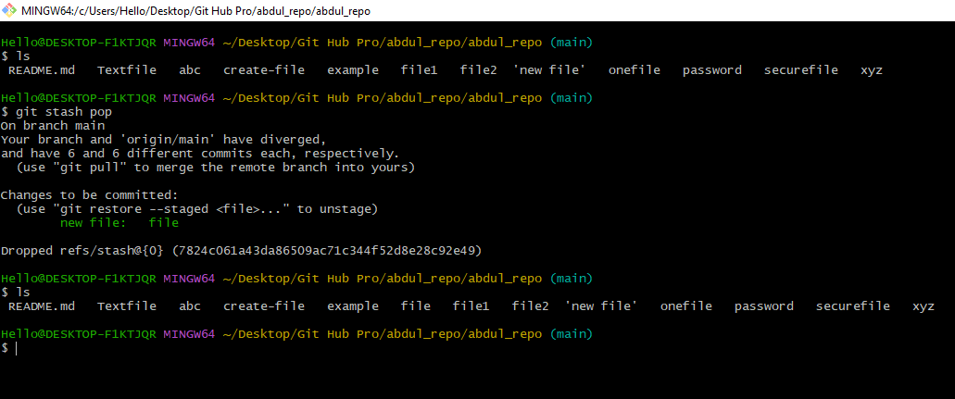

17)generate a ssh-keygen and configure into github.  
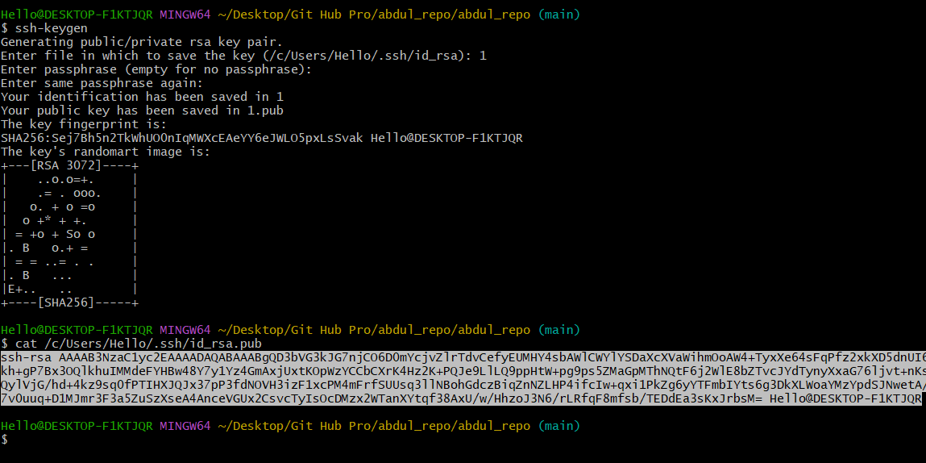

18)configure webhooks to github.

19. basic understanding of .git file.

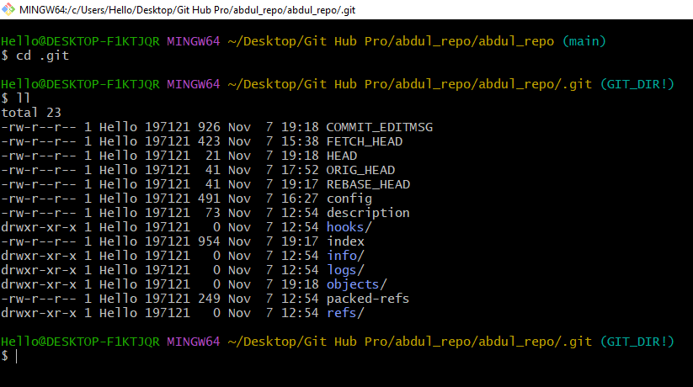

20)Check all the logs of git.  
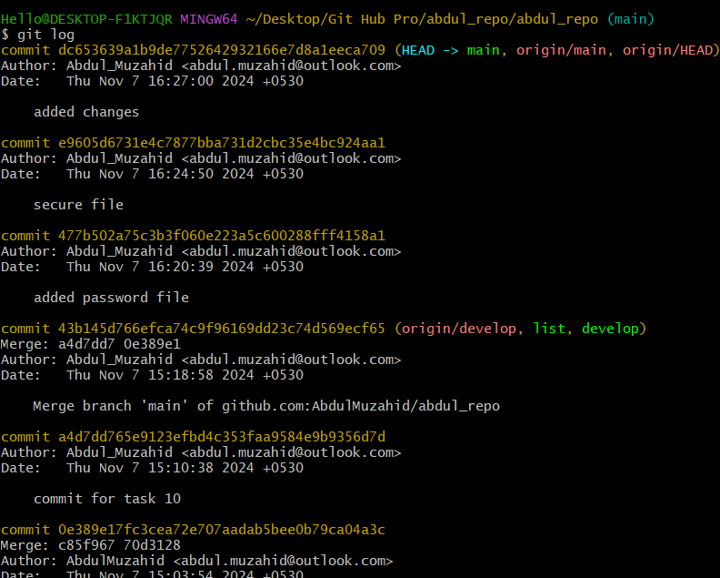

21)Rename the commit message  
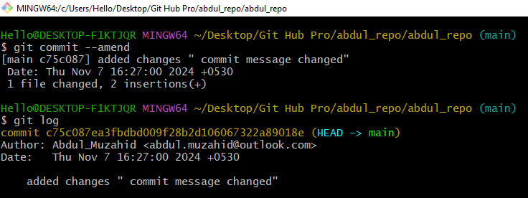

22)Merge multiple commits into single commit.  
